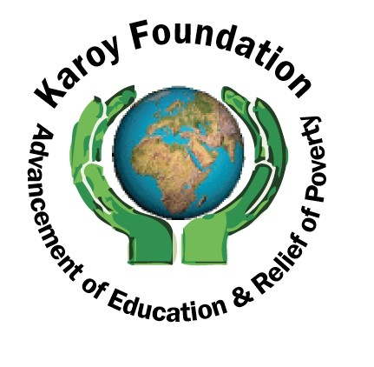
Karoy Foundation Sponsored Walk
Saturday 11th July 2026
All funds raised will be used to build a Primary School in Ghana and sponsor a Breakfast Club in a Primary School in Jamaica

To Gift Aid your donation and make every £1 you give worth £1.25, please tick the Gift Aid column below. To claim the Gift Aid, we need your full name and address including postcode. You must pay income or capital gains tax at least equal to the amount that Karoy Foundation will claim on your donation (currently 25p for every pound you give). It doesn't cost you anything to do this!

IMPORTANT INFORMATION FOR SPONSORS
- Please pay the fundraiser ASAP
- Ensure that you fill in your full name and HOME address including your title and postcode
- Tick the Gift Aid* box if you are a UK Tax payer so that Gift Aid* can be claimed
- No business can qualify for Gift Aid*

Title | Full Name (please print clearly) | Address (please print clearly) | Postcode | *Gift Aid   | Amount (£) | Date Paid
Thank you for supporting Karoy Foundation. All forms should be returned to the Trustees of Karoy Foundation: please feel free to photocopy. Karoy Foundation (Charity Number 1132942) , Registered Address 14/16 Lynwood Road, Tooting. SW17 8SA Website: www.karoyfoundation.org Email: thekaroyfoundation@gmail.com
The walk will be at Beddington Park, Church Road, Wallington. SM6 7NN, starting 10am. For further information please call Beverley on 07752849166.

